Does real-time transit information reduce waiting time? An empirical analysis

Luyu Liua,b and Harvey J. Millera,b,*[1]

a Department of Geography, Ohio State University, Columbus, Ohio, USA;

b Center for Urban and Regional Analysis, Ohio State University, Columbus, Ohio, USA.

**Abstract:**

A claimed benefit of real-time information (RTI) apps in public transit systems is the reduction of waiting times by allowing passengers to appropriately time their arrivals at transit stops. Although previous research investigated the overall impact of RTI on waiting time, few studies examine the mechanisms underlying these claims, and variations in its effectiveness over time and space. In this paper, we theorize and validate the sources of RTI-based users’ waiting time penalties: *reclaimed delay* (bus drivers compensating for being behind schedule) and *discontinuity delay* (an artifact of the update frequency of RTI). We introduce five trip planning strategies that cover possible behaviors that ignore or use RTI in deciding when to depart home to arrive at a nearby transit stop. Using real-time bus location data from a medium-sized US city, we calculate the realized waiting times and risk of missing a bus for each trip planning strategy. We find that the best RTI strategy, a prudent tactic with an optimized insurance time buffer, performs roughly the same as a simple, follow-the-schedule tactic that does not use RTI. However, relative performance varies over time and space. Moreover, the greedy tactic of using RTI to achieve a waiting time of zero is the worst strategy, even worse than showing up at a bus stop arbitrarily. These results suggest limitations on claims that RTI reduces public transit waiting times.

**Keywords:** Public transit; Real-time information; Mobile apps.

1. **Introduction**

Capabilities for collecting and sharing real-time information about transportation systems is changing how people navigate and travel through cities. Apps and services such as Google Traffic, INRIX and Waze provide departure time and route suggestions for automobile-based travel based on current and predicted traffic and travel times, allowing users to avoid traffic congestion, minimize travel time and arrive on-time more frequently (Cabannes et al. 2018). Correspondingly, many public transit agencies are sharing schedule and real-time vehicle location data to enable navigation apps that make public transit more convivial and useful to users.

Public transit navigation apps allow users to discover and navigate public transit systems with complex routes and schedules (Dutzik, Madsen, and Baxandall 2013). Public transit apps often provide real-time information (RTI) on vehicle locations and arrival times to make the system feel more convivial to users. RTI can help users reduce the amount of time they must wait for public transit at stops; this is crucial since waiting time is perceived as onerous by users and cited as a major reason why people do not like using public transit (Algers, Hansen, and Tegner 1975; Gkioulou 2013). The rationale behind the saved waiting time is that RTI allows users to determine the best time to leave their home, workplace or similar location to travel (typically, by walking) to a public stop. RTI users can access frequently updated data on bus location and arrival times at stops, adjusting their departure time accordingly (Brakewood et al. 2015; Cats and Gkioulou 2017; Watkins et al. 2011). RTI can be especially important for systems with sparser timetable and longer headways such as those in medium and smaller urban areas. In public transit systems that cannot sustain high frequency service due to limited resources, RTI can play an important role as a substitute to shorten waiting times despite infrequent service (Cats and Loutos 2016a).

Most RTI apps’ algorithms always aim to diminish waiting time to zero: user arrival time at a stop is always exactly the same as the bus arrival time, as shown in most transit planning apps’ suggested routes. However, this attempted minimization of wait time by users can be risky. After a person decides to leave their home, the actual arrival time of the bus may change. For example, if a bus is behind schedule, the operator may reduce the delay by speeding up. In addition, RTI apps update vehicle location and arrival times only at fixed time intervals. The discrepancies between the RTI and reality may moreover make the user miss the bus thus incur longer wait time – at least as long as the service headway. Paradoxically, the misuse of RTI may increase waiting times based on the realized performance of the public transit system.

In this paper, we examine the impacts of RTI on public transit users’ waiting time based on the empirical performance of a public transit system. We compare several trip planning strategies for deciding when to leave home to travel to the designated stop, including strategies that ignore and exploit RTI. We compare the performance of these strategies using high-resolution schedule and real-time vehicle location data for a popular bus route operated by the Central Ohio Transit Authority (COTA) in Columbus, Ohio, USA. We find that the most common RTI strategy that always expect the user to arrive at the same time when the bus arrives has the worst waiting time. The best RTI strategy, a prudent tactic with an optimized insurance time buffer, performs roughly the same as a simple, follow-the-schedule tactic that does not use RTI. However, relative performance varies depending on time of day, distance to the bus stop, and the location of the stop along the bus route. Although RTI can have other benefits (such as reassuring users), these results suggest limitations on the value of current RTI prediction scheme in reducing user wait time.

In the next section of this paper, we will review previous research about the impact of mobile RTI on waiting time. The subsequent section introduces our data sources, a theory of the mechanisms that underlie RTI users’ waiting time penalties, and five types of strategies used in trip planning that either ignore or exploit RTI. We demonstrate each strategy’s overall performance and performance with respect to time, distance to bus stop, and location of the bus stop within the route. We conclude this paper with a discussion of major findings, their significance for science and planning, and potential next research steps.

1. **Literature review**

In this section, we provide a comprehensive review on the impact of mobile real-time information. The deployment of automated vehicle location system, open data policies, and the widespread adoption of the mobile telephony has generated a widespread use of RTI by public transit agencies and users. Correspondingly, the body of literature on RTI in public transit is growing. We will first review the methods of quantifying the impacts of RTI on waiting time and report these studies’ findings.

* 1. **Methods**

Survey-based methods is the most common among RTI impact studies. These methods can moreover be classified into two categories: self-reported survey (Chow, Block-Schachter, and Hickey 2014; Ferris, Watkins, and Borning 2010; Watkins et al. 2011) and observation (Papangelis et al. 2016). Self-reported surveys are the most direct methods to assess transit system use and especially useful to measure user experience and perceptions. Survey data can also help assess individual differences based on gender, demographic and social attributes (Neuman, W. L., & Robson 2004). However, despite extremely useful under the mentioned circumstances, the results of self-reported surveys could be inconsistent with *actual waiting time,* since they measure *perceived waiting time* (Brakewood, Barbeau, and Watkins 2014). Observation survey by a third-party researcher or a censor can better measure the actual waiting time. For example, in Seattle, RTI users’ self-reported average perceived waiting time were 7.54 minutes compared to non-RTI users’ 9.86 minutes, while the average actual waiting time obtained by observers for RTI users is 9.23 minutes compared to non-RTI users’ 11.21 minutes (Watkins et al. 2011).

Another approach to analyzing the impacts of RTI on waiting times is mathematical simulation. Agent-based modeling represents the simultaneous actions and interactions of various agents in intricate and complicated systems such as public transit (Gkioulou 2013). For example, Cats & Gkioulou (2017) adopted an agent-based model to simulate the influence of transit reliability and real-time information on waiting time uncertainty. With more abundant and accurate real-time data, many studies also simulated the real-time arrival time prediction schemes and investigated the added-value of RTI on real-time users. For example, Cats and Loutos (2016) introduced a new bus arrival prediction scheme and compared its performance with the schedule and a common prediction scheme.

* 1. **Findings**

Numerous studies investigated RTI’s impact on public transit users and drawn different conclusions on the effectiveness of RTI for different region and different RTI media. In this section, we will focus on impact of personal devices RTI and summarize prior quantitative findings.

Most studies reported that RTI can reduce *perceived waiting time* by using self-reported surveys. Ferris, Watkins, and Borning (2010) concluded that 91% of RTI users spent less time waiting in Seattle. Brakewood, Barbeau, and Watkins (2014) conducted behavioral experiment in Tampa to test the self-reported waiting time and found that RTI user reported 1.5 minutes less than the control group. Similar conclusions were drawn in other contexts besides urban transit systems for commuting. Papangelis et al. (2016) found an average self-reported waiting time reduction of 7 minutes in rural Scotland. Some studies also concluded that RTI has positive impact on the *actual waiting time* by observation and simulation. Watkins et al. (2011) found that RTI users could save 2 minutes than non-RTI users by observation. Cats and Loutos (2016) introduced a better RTI prediction scheme that can save waiting time equivalent to introducing a 60% increase in service frequency in Stockholm. Cats and Loutos (2016b) also concluded that RTI could make waiting time estimate twice as close to the actual time than the schedule.

However, some studies concluded that RTI has limited impact on both perceived and actual waiting time in some cities. Brakewood et al. (2015) explored the impact of mobile platform RTI on Boston commuter rail services and concluded that perceived waiting time did not have a statistically significant difference between RTI and non-RTI users on the survey days. Fries, Dunning, and Chowdhury (2011) used video feed to construct simulation model of waiting time and found pre-trip travel time savings, which is part of actual wait time, were small; the major benefit of RTI is anxiety reduction.

Although the overall impact of RTI on waiting time is well-explored, few studies investigate the variance of these impacts (Brakewood and Watkins 2019). Most studies focus on the overall average actual waiting time, perceived waiting time, or predicted time deviation; however, few studies investigated the variance of this impact on actual waiting time relative to transit system’s actual on-time performance. Empirical performance matters because on-time performance and delays can be heterogeneous within a system and even within a single route (Park et al. 2019). In addition, a key decision of public transit users is when to leave home (or other origin) to travel to a stop; therefore, the impact of RTI on waiting times may vary with walking time to the stop (Cats and Loutos 2016a). Due to the heterogeneity of on-time performance, the impact of RTI may also vary by the location of the stop within a route. This paper fills this research gap by analyzing the overall and disaggregate performance of different trip planning strategies that both ignore and exploit transit RTI based on the actual performance of a public transit system.

1. **Methodology**

In this section, we introduce our data sources. Next, we conceptualize synchronization process between the user and the vehicle, and introduce the concepts of *reclaimed delay* and *discontinuity delay*: the former related to over-estimation of bus arrival time, the later related to the RTI updating frequency. Both can have impacts on RTI users. Based on the synchronization theory, we propose and model several trip planning strategies representing the possible behaviors of users. We also optimize the RTI apps user’s strategy based on real-time data; this represents an ideal RTI app that provides pro-active advice to users. We also calculate the waiting time difference between RTI apps users’ deterministic process and non-RTI users’ probabilistic process.

* 1. **Data**

We use two data sources to represent two major actors in a public transit system: General Transit Feed Specification (GTFS) real-time data corresponding to the information available to users and automated passenger counter data to represent the actual on-time performance behavior of the transit system.

General Transit Feed Specification (GTFS) real-time provides a homogeneous protocol to effectively transmit transit real-time information with normalized standard. Most RTI apps use the estimated arrival time provided by GTFS trip update for the buses’ real-time information (Google Developers 2018; Transit app 2019). Therefore, we can simulate RTI users’ behavior from the GTFS trip update data. Nevertheless, although GTFS data’s resolution is relatively high, its *temporal accuracy* is not satisfying. Similar to Firmani et al. (2016)’s definition, we define temporal accuracy as: how accurate is the measure’s recorded time compared to the actual time (Liu and Miller 2020). It represents the systematic error caused by the temporal delay of measurement. GTFS data is updated based on a fixed interval; this could range from 5 seconds to 2 minutes depending on the system. Consequently, the reported times of bus arrivals at stops could be different from the actual arrival times.

To solve the temporal accuracy issue, we use automated passenger counter (APC) data. APC data are collected by the passenger counters installed on each bus to summary the ridership. Moreover, the data also contain the accurate arrival/departure time recorded promptly at each stop. Compared with GTFS, it is more appropriate to use APC to calculate the system performance and RTI-based users’ actual performance for its higher temporal accuracy. However, because the APC devices are not available for every bus, its system coverage is not 100% unlike GTFS. Correspondingly, to make the APC data possible to sustain the calculation, we will merge the APC data and GTFS to achieve both higher temporal accuracy and 100% system coverage: for every trip and stop, query in the APC database and overwrite the GTFS record if APC record exists.

For the development and implementation of our methods, we selected Columbus, Ohio and Central Ohio Transit Authority (COTA) as the site for the case study. First, COTA bus system’s average headways are considerably large, making the waiting time a significant factor; second, as a typical car-oriented American city, the case study can be easily expanded to other cities and larger scales with same data support and methodologies. We collected the COTA GTFS data in MongoDB and Python environment from May 2018 to May 2019; for GTFS real-time, we archived the streamed data with frequency of 1 minute for the same time period. We also received the APC data from COTA from May 2018 to May 2019.

* 1. **Synchronization**

We conceptualize catching a bus as a synchronization process between the walking trip to the target stop and the target bus’s *trip sequence array*. Trip sequence array is the collection of trips running on the same route and in the same direction as the target bus.

Depending on user’s arrival time at the stop *t*, the actual bus that user will take can be different from the scheduled one. We use the same concept in the transfer synchronization process: *desynchronization degree* (DD), to measure the desynchronization between the bus and user at the stop (Liu and Miller 2020). DD is an integer indicator that represent how many buses the user loses in the trip sequence array: it represents the order number of the actual bus before/after the scheduled bus. For example, if the actual bus is the *n-th* bus after the scheduled bus, the DD is *n*; if the actual bus is the *n-th* bus before the scheduled bus, the DD is *-n*; if the actual bus is the scheduled bus, then the DD is 0.

When synchronizing, the process of walking is linear: the users can control the walking time by selecting their home departure time. Except for very crowded conditions in dense cities, we can assume walking time is linear with respect to distance. In contrast, the actual real-time performance of the bus is non-linear: the bus will not run at a fixed velocity and the expected time of arrival of bus at the stop is constantly changing. The vehicle operator can change the vehicle’s speed based on conditions in real-time. Most relevant to our question, a vehicle operator can make up for an initial delay by increasing speed. Indeed, public transit agencies value on-time performance and may incentivize drivers to compensate for delays when possible, considering speed limits and safety considerations.

We therefore introduce the concept of *reclaimed delay.* Similar to delay propagation (Park et al. 2019) and riding time deviation (Cats 2019), it is the time difference between the estimated time of departure estimated before the bus arrival and the actual time of departure at the target stop . It measures the over-estimation caused by bus accelerating, short signals, and skipping stops between two stops. Many studies reported the impact of the delay propagation on transit performance (Cats 2019; Park et al. 2019), ridership and running time (El-Geneidy et al. 2006; El‐Geneidy, Horning, and Krizek 2011). In this paper, we are going to discuss the impact on waiting time specifically. Figure 1 shows corresponding space-time diagram of the expected synchronization, the actual desynchronization, and delay reclamation process. After the user leaves home, the actual bus trip (blue line) will diverge from the expected bus trip (red line) and converge with the scheduled bus trip (yellow line): since the bus has an initial delay near the user’s home, the bus accelerates and catches up the delay with the schedule. However, the user’s walking trip is still aiming for the expected bus trip. Consequently, the bus arrives earlier than the user’s expected time and the user will miss the bus.

The reclaimed delay could be small but critical for RTI apps users: consequently, the RTI apps user will miss the bus and suffer waiting time penalty for a relatively long time. Thus, the synchronization of these two processes is highly unstable. Besides the delay reclamation mechanism, other RTI-related factors such as inaccurate geographic locations and delays in updates due to internet congestion and failures may also contribute to the desynchronization.

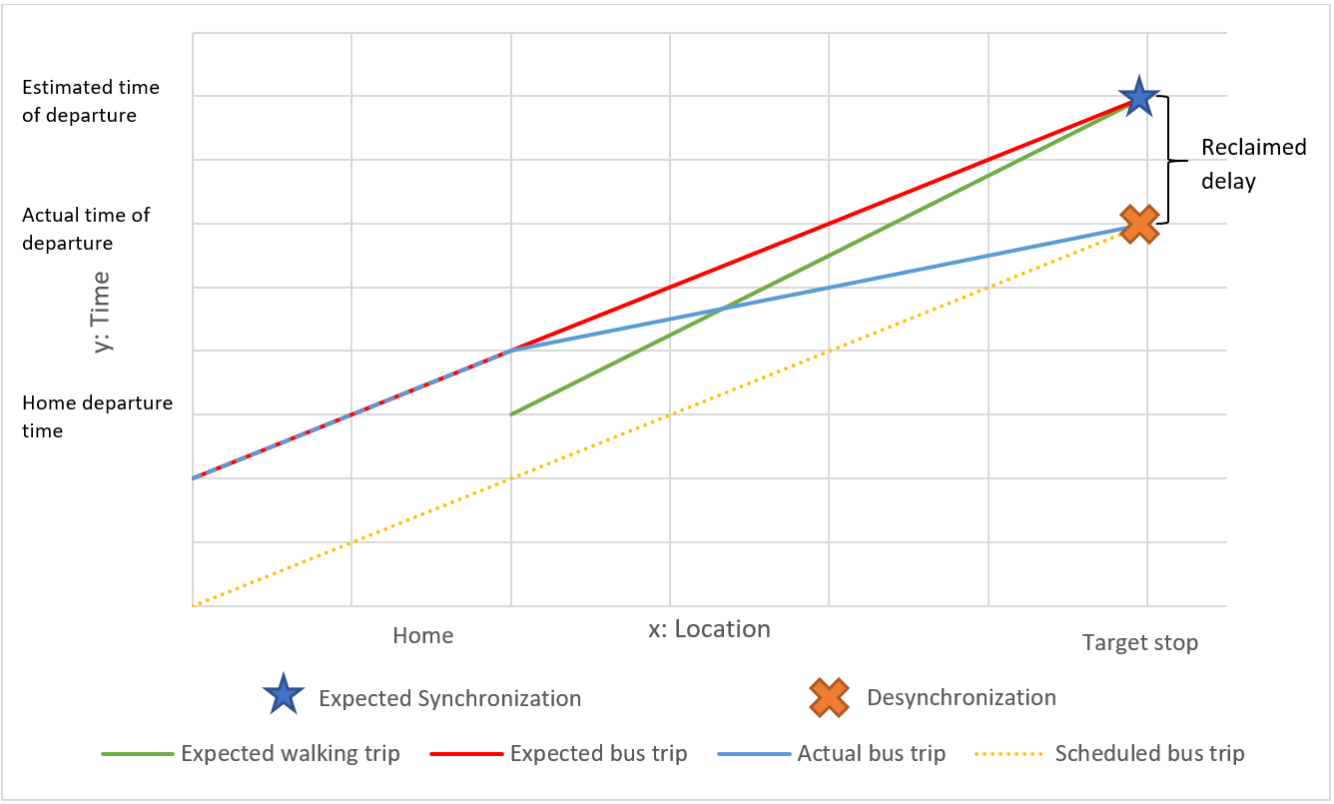

Figure 1: space-time diagram of the expected synchronization and the actual desynchronization.

Besides reclaimed delay, due to the discrete nature of the GTFS real-time data, there are a *discontinuity delay* for all RTI-based trip planning strategies: if RTI apps do not interpolate the void between the data feeds and their corresponding timestamp, the RTI-based users will wait until the data is updated. However, when the data is updated, the RTI-based user may already be late for the bus. Similarly, if the user decides to leave between two updates, although the RTI apps will show a good result based on the last update, in reality the user will miss the bus. Either scenario is the consequence of discontinuity of the real-time data. Exactly like reclaimed delay, although the discontinuity delay could be very small in value, it still can result in desynchronization and significantly long waiting time. Both reclaimed delay and discontinuity delay produce potential missed risk for RTI-based users.

* 1. **Trip planning strategies**

A trip planning strategy can be interpreted as a tactic for a user to plan and execute a transit trip. There are different trip planning strategies for both RTI apps and non-RTI users to determine their home departure time. Assuming no disturbance on user’s walking and boarding process, different trip planning strategies have only one controllable factor to determine the actual waiting time, namely, the home departure time:

|  |  |  |
| --- | --- | --- |
|  | | (1) |

Where τ is the passenger’s arrival time at the stop, t is the home departure time, δtis the walking time, and πa(τ) is the corresponding actual boarding bus departure time which depends on when the passenger arrives at the stop. Therefore, in the following sections, we will define each trip planning strategy by giving the formula of either its actual waiting time or its home departure time.

* + 1. Arbitrary tactic

The simplest strategy is to arbitrarily walk to a stop and catch the subsequent bus that arrives. It has been extensively studied that passenger arrival time follows the uniform random distribution when the headway is small (Bowman and Turnquist 1981), which means this arbitrary tactic is a very common strategy among passengers. Because the user’s decision-making process is random, it is reasonable to assume user’s home departure time or user’s arrival time is evenly distributed among the headway between two buses. Since we have access to the real-time vehicle departure time data, we can directly calculate the waiting time as the median of the departure time of target bus and its subsequent bus without calculating the home departure time:

|  |  |  |
| --- | --- | --- |
|  | | (2) |

Where: δt is waiting time, is the bus’s actual real-time departure time with desynchronization degree = 0, and is the previous bus’s actual real-time departure time with desynchronization degree = -1.

Theoretically, this strategy is not very efficient since it is always the half of the buses’ actual headway. Therefore, it is a good benchmark for other trip planning strategies: if another trip planning strategy performance is even worse than arbitrary tactic, we can assert that it is not effective.

* + 1. Schedule tactic

These timetable-dependent users make their home departure time decisions based on the schedule published to the public:

|  |  |  |
| --- | --- | --- |
|  | | (3) |

Where: *δt* is the walking time from user’s home to the stop, *πt* is the scheduled bus departure time.

Schedule tactic users do not benefit from waiting time reduction based on RTI. However, since COTA bus will rarely if ever leave a stop earlier than the scheduled time due to timetable policy (COTA 2019), schedule tactic minimizes the missing risk. Schedule tactic is another benchmark for all trip planning strategies, which theoretically has the lowest risk of missing a bus.

* + 1. Greedy tactic

Greedy tactic is a very common strategy used by many real-time transit planning apps and algorithms: most trip planning apps do not have a buffer time or wait time between the initial walking phase and the transit phase. The default assumption is the user will arrive at the same time when the bus arrive thus achieve shortest waiting time. Therefore, based on the same logic, a greedy tactic user will check the relationship between suggested home departure time and current time, only leaving home when the bus’s estimated time of departure is equal to or greater than walking time plus current time. The pseudo code is:

|  |  |  |
| --- | --- | --- |
|  | **while** there is a new update **do:**  **if**  return $t=$**else**  wait until next update | (4) |

Where: πp is the scheduled bus’s estimated time of departure given by RTI app and t’ is the current time when a new update is available.

Ideally, this strategy can achieve a minimal wait time if no disturbance as shown in Figure 1 (green line). However, due to the instability of transit system, its risk of missing a bus is also the highest. Due to the possible reclaimed delay and discontinuity delay, the bus may leave the stop earlier than the estimated time of departure. Consequently, this could suggest that mainstream apps are systematically suggesting a trip plan with very poor performance. It is extremely imperative to measure greedy tactic’s performance and improve it.

* + 1. Prudent tactic

To manage the risk of missing a bus, a RTI user may want to leave home earlier than the greedy tactic. This is a common strategy to avoid risk of missing a bus, such as using the 95th percentile waiting time as budgeted waiting time (Furth and Muller 2006). An *insurance buffer* trades some time to reduce risk of missing a bus. Given a user-designated insurance buffer *IB,* the pseudo code for home departure time *t* is:

|  |  |  |
| --- | --- | --- |
|  | **while** there is a new update **do:**  **if**  return $t=$**else**  wait until next update | (5) |

Insurance buffer is an indicator of the transit users’ risk attitude: it represents how much time the user is willing to gamble to gain the waiting time reduction. The less insurance buffer is, the more risk-seeking the users are.

We can consider prudent and greedy tactic as part of a *prudent tactic family*, for greedy tactic is a special case with insurance buffer of 0. With different buffers, each prudent tactic can vary in actual waiting time. However, we can optimize buffers and find the best prudent tactic with minimal waiting time based on system performance. We simulate the users’ real-time waiting time based on the transit systems empirical performance using different buffer in four steps:

* Calculation: Designate a set of buffers (e.g., 0 – 300 seconds) and walking time ranges (e.g., 0 – 9 minutes). Calculate the performance for all designated buffers. The results contain user’s arrival time at the stop and the actual taken bus’s departure time for users with different walking time.
* Optimization: Find the smallest waiting time and the corresponding buffer each day. If there are multiple smallest waiting time, designate the one with smaller buffer to guarantee least waiting time.
* Finalization: For each day, reduce all past days’ buffers into one by finding the maximum of the optimal buffers. We aim to find the smallest buffers while most trips are synchronized. To accommodate changes in the schedule, we will restart the process whenever a change is implemented.
* Revalidation: Based on the finalized buffers, calculate the performance of each day.

However, the number of insurance buffers is large: we minimize waiting time over each *IBijk*, which represents a different buffer for each trip i, each stop j, and each walking time k from the stop (0 – 10 min). Meanwhile, the collected transit system data volume for the period May 2018 to May 2019 is terabyte-scale; to deal with the consequent large computational cost, we selected the representative bus route No.2 to study and parallelized the outmost loops (buffers × dates) on a workstation with 40 virtual CPU cores. We also select another five major routes in the COTA systems in a typical week and conduct the same PT optimization process to test the generalizability of the research.

1. **Analysis**

In this section, we focus on the performance of different trip planning strategy based on scheduled and actual bus arrivals at stops along one bus route in the Columbus, Ohio, USA Central Ohio Transit Authority (COTA) system: route No. 2. We chose this route for its popularity (it is the one of the busiest routes in the system) and coverage (it traverses a long spatial transect of the city and has a long service temporal span). Figure 3 provides a map of COTA bus No. 2 from Southeast to Northwest during the period May 2018 to May 2019. The bus route has two schedules: the frequent schedule originates from the red circled stop in Figure 3 with headways of 10 – 15 minutes, while the standard (non-frequent) schedule originates from blue circled stop with headways of 20 – 30 minutes (COTA 2013).



Figure 2: Bus route 2's standard and frequent service map (COTA 2013).

* 1. **Overall performance**

Table 1 shows themean and deviation of each trip planning strategy waiting time and risk of missing a bus. Overall, strictly following the schedule (schedule tactic) or using RTI to determine an optimal insurance buffer (prudent tactic optimal) are the best strategies: these achieve roughly equivalent waiting time performance based on waiting time average and standard deviation; they also have similar performance based on bus missed risk average and standard deviation. Showing up at the bus stop at an arbitrary time (AT) has the second worst performance. AT only has average waiting time because we do not simulate the decision-making process like the other trip planning strategies but use Equation (2).

|  |  |  |  |  |  |
| --- | --- | --- | --- | --- | --- |
| Strategy class | Trip planning strategy | Waiting time | | Risk of missing bus | |
| Mean | Standard deviation | Mean | Standard deviation |
| No real-time information | Arbitrary Tactic (AT) | 510 seconds | - | - | - |
| Schedule Tactic (ST) | 252 seconds | 345 seconds | 6.28% | 16.55% |
| Real-time information | Greedy Tactic (GT) | 751 seconds | 707 seconds | 74.63% | 74.50% |
| Prudent Tactic Optimal (PT) | 282 seconds | 381 seconds | 10.18% | 17.70% |

Table 1: Overall performance of trip planning strategy; waiting time and missed risk's mean and deviation.

The worse strategy is the greedy tactic that tries to exploit RTI to try to achieve a waiting time of zero: this is a risky strategy that is harshly penalized by reclaimed delay and discontinuity delay in the RTI system. This shows that many trip planning apps and algorithms are systematically proposing a very risky strategy with poor performance to users; therefore, it moreover demonstrates that it is imperative to introduce insurance buffer and optimization to better utilize RTI.

To show the relationship between reclaimed delay, discontinuity delay and miss risk, we also calculate the delay reclamation and miss risk for each specific trip. We estimate that during the whole year, when a delay reclamation occurred, there was 88.87% chance that the GT user would miss the bus. To validate the existence of discontinuity delay, we calculated 31 trip planning strategies in the PT family, each with a designated static insurance buffer from 0 (greedy tactic) to 300 seconds. Figure 7 shows how the average waiting time, miss risk and rate of changes in both indicators with respect to the length of the insurance buffer. Note the dramatic changes in both indicators at the multiples of the RTI update frequency (60 seconds). These abrupt changes demonstrate the existence of the discontinuity delay. With better real-time data supports and policies, more transit systems are providing RTI with higher update frequency. Some can be as high as 5 second such as Massachusetts Bay Transportation Authority in Boston. However, the large majority of most transit systems still face considerable discontinuity delay larger than 30 seconds as shown in the RTI update frequency summary table in the appendix 4.

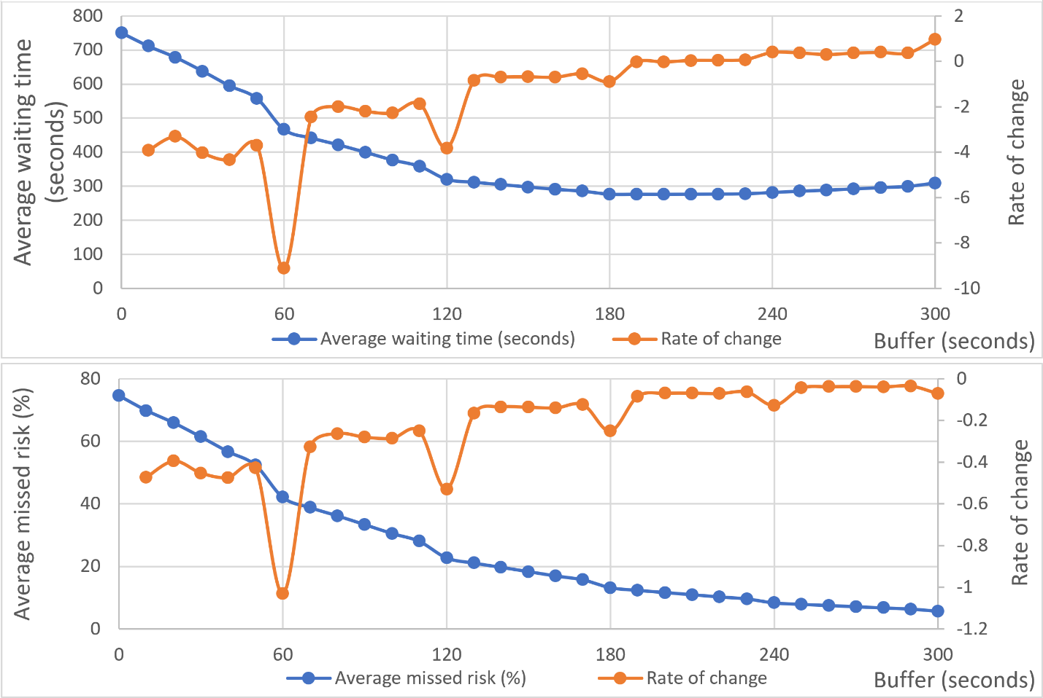

Figure 3: average waiting time/missed risk and their changing rates' relationship with the uniform buffer.

These results suggest that real-time information may have limited value with respect to minimizing waiting time and risk: the best RTI strategy prudent tactic optimal is not substantially better than simply following the schedule, and the RTI-based greedy tactic has the worst performance among all trip planning strategies. This moreover proves our claim earlier about the RTI apps: if following the RTI apps’ suggestion based on greedy tactic, the user is very likely to miss the bus and wait a long time. However, note these are based on overall performance. The effectiveness of these strategies can vary with respect to time and space; we examine these patterns below.

* 1. **Performance over time**
     1. Hourly pattern

Figure 5 illustrates the average waiting time and risk of missing a bus with respect to hour of the day. These hourly results support the overall results discussed above: ST and PT are consistently the best over the course of a day. AT and GT perform especially poorly during service hours with long headways (6:00 to 8:00 and 21:00 to 24:00) since the time penalties associated with missing a bus during these periods are dramatically higher. These inferior strategies perform better during short headway hours, but not better than ST and PT. GT is a very risky strategy at all times, although is not penalized as harshly during short headway hours.

Although ST and PT are always competitive, although there are some differences in their performance over the day. For long headway hours in the morning and midnight, PT performs worse than ST; while for most hours during 8:00 to 21:00, performs PT almost the same as ST; especially, for afternoon hours from 17:00 to 20:00: with higher delay in the system due to peak traffic and user-related boarding delays, PT outperforms ST. In this sense, it is generally better for transit users to follow ST in the morning commuting and follow PT in the afternoon commuting. This suggests that PT is more sensitive to the headway and delays than ST.

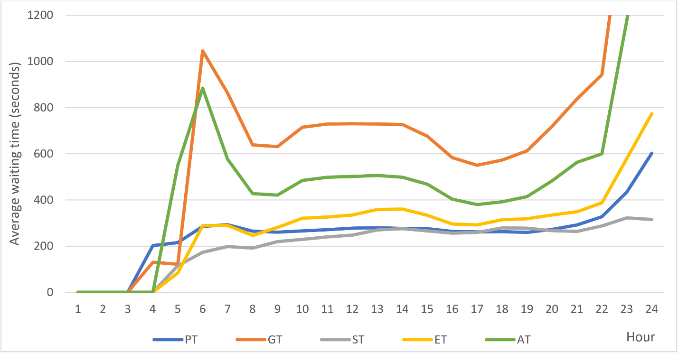

Figure 4: average waiting time and risk of missing bus by hour of day.

* + 1. Service headway

As previous analyses suggest, headway is a crucial factor for the performance of trip planning strategies. In this section, since different hour have a different headway for Route No.2 buses, we conducted two temporal analyses based on the average headway within each hour. The analyses suggest two empirical rules:

* The larger the headways are, the *more* effective PT compared to AT. This is obvious since AT’s waiting time is exactly the half of the headway. To moreover prove this, we investigated the correlation between the average waiting time difference in each hour and the average headway. The Pearson correlation indicates a strong positive correlation (coefficient=0.9798 and p-value<0.0001) as shown in Figure 10 (left). Some former studies also suggested the same conclusion: in rural Scotland, RTI users can save 7 minutes in average (Papangelis et al. 2016), while in other studies in urban areas, the saved time is much less (Brakewood, Barbeau, and Watkins 2014; Chow, Block-Schachter, and Hickey 2014). RTI will flatten the radical waiting time difference between different systems caused by different scheduled frequencies.
* The larger the headways are, the *less* effective PT compared toST. Likewise, we tested the correlation between each hour’s average headway and corresponding performance difference. Figure 6 (right) shows a strong negative correlation (Pearson correlation coefficient = -0.6201 and p-value = 0.0012).

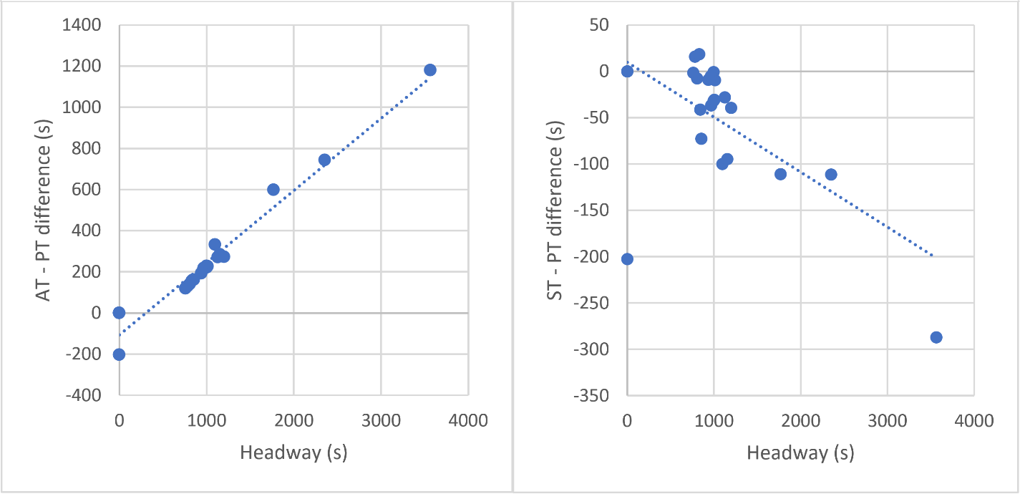

Figure 5: Scatter plots between headway and AT- PT (left side) and ST-PT (right side) waiting time differences.

* 1. **Performance over space**
     1. Walking time to bus stops

Figure 7 illustrates the relationship between average waiting time and risk of missing bus based on walking time from home to the closest stop. Again, we can see that the non-RTI strategy of following the schedule (ST) and the prudent RTI strategy (PT) are generally competitive with each other with respect to average waiting time. However, as walking time to the nearest bus stop increases, the PT waiting time increases with respect to ST, which can also be observed in Figure 8. The degradation of PT waiting time performance with increasing walk time is due to the increasing risk of missing a bus. This supports the claim that the longer distance a user lives from the stop, the more unstable their trip: the longer walking time to the stop, the bus has a greater chance to reclaim delay; because PT trips are synchronized to RTI, they are more sensitive to reclaimed/discontinuity delays. Therefore, PT users have a greater chance to desynchronize with longer walking time. This is also consistent with prior studies about prediction horizon’s impact on the waiting time (Cats and Loutos 2016a).

Interestingly, for the greedy strategy (GT), longer walking time lowers average waiting time since the missed risk decreases with distance from a stop, which can also be observed in Figure 9. Similar to PT’s scenario, with longer walking time to the stop, the bus also has a greater chance to gain more delay; because GT trips are highly desynchronized due to a small reclaimed/discontinuity delay, the gained delay can offset the reclaimed/discontinuity delay, which plays a similar role as the insurance buffer. Therefore, GT users have a greater chance to resynchronize with longer walking time.

In conclusion, with longer walking distance/time, the chance of reclaiming and gaining delay will simultaneously increase while the chance of maintaining delay of the same value will decrease. PT and GT are the two polar of RTI-based trip planning strategies and their performance will converge with longer walking time: highly synchronized PT is sensitive to reclaimed delay and its performance will become worse; while highly desynchronized GT is sensitive to gaining more delay and its performance will become better.

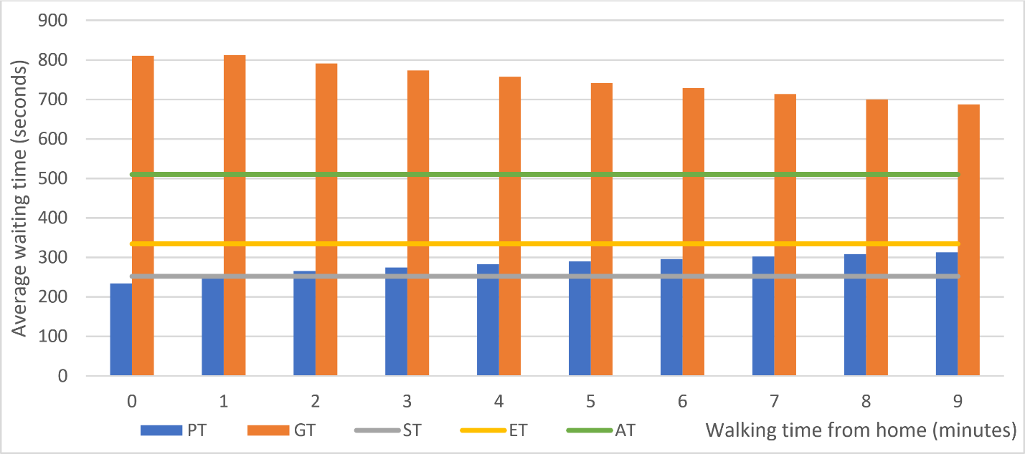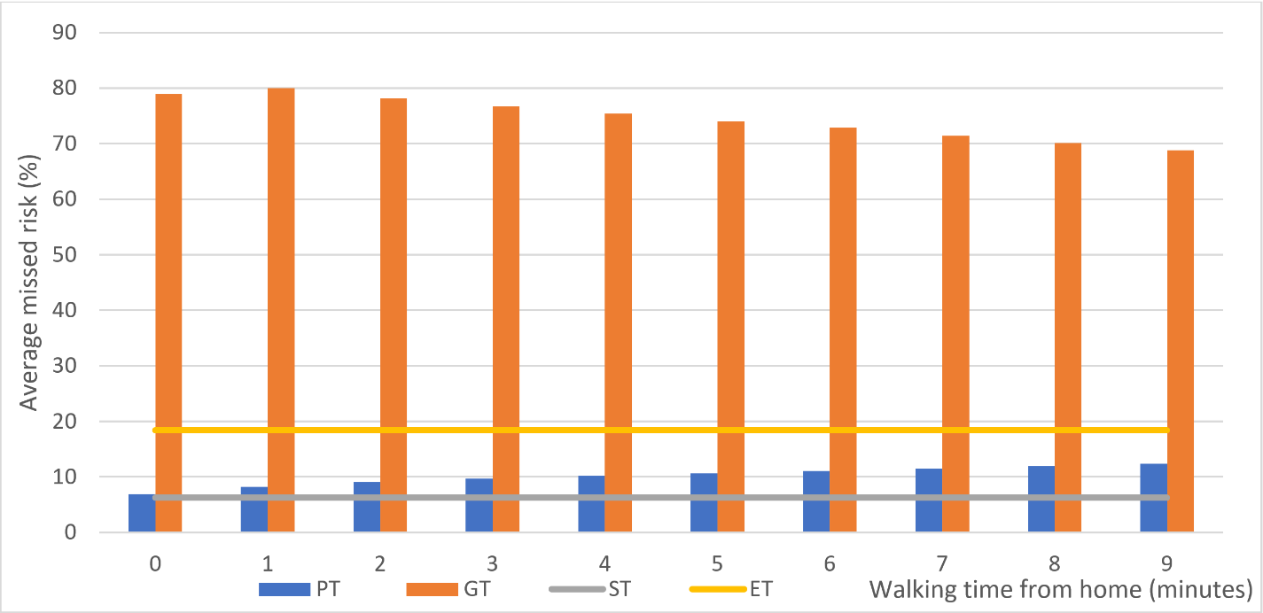

Figure 6: PT, GT, AT, and ST’s waiting time and risk of missing bus's relationship with the walking time.

* + 1. Spatial patterns

As noted above, due to the heterogeneity of on-time performance over a bus route, the location of the bus stop within the route also influences the performance of a trip planning strategy. To illustrate this, we map the average wait time and risk of missing a bus for home locations within 0 – 9 minutes (0 – 756 meters) distance buffer of COTA bus route #2 heading from southwest to northeast, assuming users travel to their closest bus stop. Figure 8 shows the average waiting time and risk’s spatial pattern for the greedy tactic. It confirms the waiting times are sensitive to the change in the headways indicated by red ovals: longer headways are correlated with longer waiting times but not risk of missing bus. Figure 9 shows the average waiting time and risk across space for the prudent tactic optimal. Noticeably, there are two significant clusters of high waiting time/high risk near the originating stops for standard headway service (indicated by a blue oval) and frequent headway service (indicated by the red oval). These clusters occur because real-time information will not be available for these stops until the bus leaves the originating stop. By the time the real-time information is updated, the user has likely missed the bus. Consequently, PT insurance buffer will not help improve the missed risk of such trips since its effectiveness depends on accessible RTI. Meanwhile, users who live far from the stop will have higher missed risk and will consequently suffer from even more waiting time.

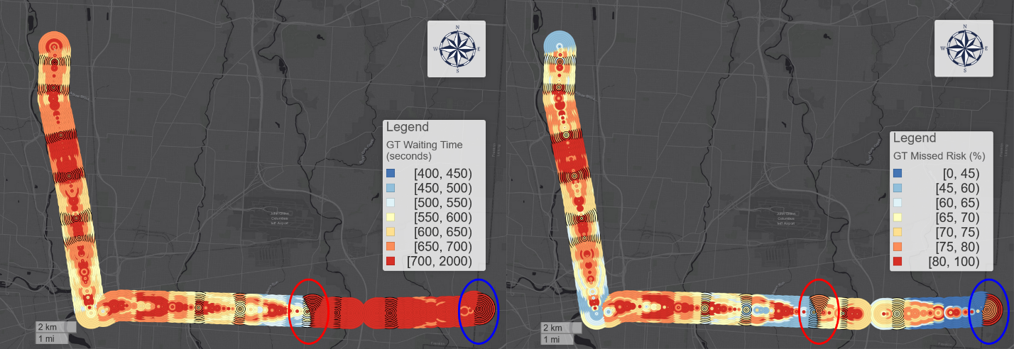

Figure 7: Spatial pattern of average wait time (left side) and missed bus risk (right side) within a walking distance buffer for the GT strategy (black stroke: timepoints).



Figure 8: Spatial pattern of average wait time (left side) and missed bus risk (right side) within a walking distance buffer for the PT strategy (black stroke: timepoints).

We can also observe interesting spatial patterns at timepoints in Figure 8 and Figure 9, defined as stops where buses try to strictly observe the scheduled timetable. For greedy tactic, the waiting times at timepoints are significantly larger than nearby non-timepoint stops. Due to strict timetable policy, bus drivers may tend to reclaim more delay before these stops, making greedy tactic users’ risk of missing bus larger. However, the waiting time for prudent tactic optimal at timepoints are significantly smaller than nearby non-timepoint stops, showing the effectiveness of the optimal insurance buffers.

We also test the transferability of the spatial patterns to other five major routes in the COTA systems in Appendix 5. The results show that these conclusions are transferable to other routes with highly similar spatial patterns.

* + 1. Spatial differences between ST and PT

We now compare the performance of best RTI strategy (PT) and best non-RTI strategy (ST) with respect to space, which is a common benchmark adopted by prior research (Cats and Loutos 2016b, 2016a). Figure 10 shows the average wait time difference between ST and PT within a walking distance buffer of the bus route. We observe the originating stops have exceptional high waiting time due to larger headway. We can also observe that PT does not outperform ST for more than half of all stops. In fact, for most stops, especially for those stops in the upstream near the originating stops, ST performance is much better than PT. This could be because of the relatively stable performance of prudent tactic optimal and the deterioration of the on-time performance in the downstream stops. To moreover demonstrate the variations, geographically, we divide the stops into two groups at stop “North High Street & Euclid Avenue” shown as a green line in Figure 10. For upstream stops, PT users waited 68 seconds more than ST users; while for downstream stops, ST users waited 21 seconds more than PT users. The comparison shows the highly polarized geographic pattern of relative performance between these two strategies.



Figure 9: PT – ST waiting time difference for each stop and walking time in COTA bus route No. 2 from Southeast to Northwest.

1. **Conclusion**

Previous research suggests that transit real-time information (RTI) can decrease transit users’ waiting time (Brakewood and Watkins 2019). However, few studies systematically investigate the mechanisms behind this claim and the variations across time and space of RTI impact on waiting time and the risk of missing a bus. In this paper, we theorize and validate the concept of reclaimed delay and discontinuity delay during the synchronization process between users and buses. We introduce the concept of trip planning strategy and five different types for both RTI and non-RTI users. We calculate the empirical wait time and risk of the different trip planning strategy using real-time bus location data for a representative bus route in a mid-sized US city. We find that the best RTI strategy, a prudent tactic (PT) with an optimized insurance buffer, performs roughly the same as a simple, follow-the-schedule tactic (ST) that does not use RTI. The analyses results show that PT users in upstream stops on a route will wait more time than the ST users, and PT users in this area may suffer from higher risk of missing a bus than ST users. We also find that PT users are more advantageous during evening peak (17:00 – 20:00) than ST users. These results show that although the best RTI strategy can indeed save time for certain users in certain stops and during certain hours, they cannot globally outperform simply following the published schedule. Moreover, the greedy tactic (GT) of using RTI to achieve a waiting time of zero is the worst strategy, even worse than showing up at a bus stop arbitrarily. This suggests that RTI could make users’ waiting time significantly longer if apps are not using the appropriate trip planning strategy.

This study provides valuable insights for transit users, planners, and real-time transit app providers. With more access to real-time data, it is understandable that transit system navigation apps would engage with real-time performance data in addition to the published schedules. However, our results suggest that real-time performance data is not sufficient: RTI apps should also consider historical data to gauge the veracity of the RTI in reducing waiting time based on spatial and temporal context. Users should also have the option of specifying different trip planning strategy, including prudent strategies with insurance time buffers. At present, most RTI apps do not consider missed risk and implicitly promote a greedy strategy: as we have shown, this is a risky and poor performing strategy. The techniques and measure we develop in this paper can help support a more holistic and sensitive approach to public transit RTI apps.

To improve accuracy and reliability of RTI apps, transit authority or RTI apps providers can add pre-calculated insurance buffers based on stated or revealed risk attitudes of users. Also, our optimization of prudent tactic is not fully explored, there are likely better ways to find the optimal insurance buffer. Unlike simple non-RTI strategies that can be conceptualized and understood by humans from experience, RTI-based trip planning optimization can only be accomplished by the backend of the RTI apps, where more complicated and effective algorithms can be applied. Computational techniques such as machine learning and neural network could be applied to empirical performance and user data to determine effective trip planning strategies based on context and user risk preferences.

Finally, although each trip planning strategy’s performance at individual level is systematically discussed in this paper, we do not empirically survey or simulate the proportions of the users using each trip planning strategy among all users. Future research should survey the different trip planning strategies user groups and the way in which they use transit apps in their decision making. This includes but is not limit to the distribution of actual inssurance buffer and actual waiting time. The progress on these issues will help to understand RTI apps’ collective impact on the whole population. Meanwhile, we also encourage future studies to expand the methods to more transit systems with different headway and update interval to test the transferability of the conclusions drawn from the COTA system.

Declarations of interest: none.

All figures are preferred to be printed with color.

Reference:

Algers, Staffan, Stein Hansen, and Goran Tegner. 1975. “Role of Waiting Time, Comfort, and Convenience in Modal Choice for Work Trip.” *Transportation Research Record* 534(534): 38–51.

Bowman, Larry A., and Mark A. Turnquist. 1981. “Service Frequency, Schedule Reliability and Passenger Wait Times at Transit Stops.” *Transportation Research Part A: General* 15(6): 465–71.

Brakewood, Candace et al. 2015. “An Analysis of Commuter Rail Real-Time Information in Boston.” *Journal of Public Transportation* 18(1): 1–20.

Brakewood, Candace, Sean Barbeau, and Kari Watkins. 2014. “An Experiment Evaluating the Impacts of Real-Time Transit Information on Bus Riders in Tampa, Florida.” *Transportation Research Part A: Policy and Practice* 69: 409–22.

Brakewood, Candace, and Kari Watkins. 2019. “A Literature Review of the Passenger Benefits of Real-Time Transit Information.” *Transport Reviews* 39(3): 327–56.

Cabannes, Theophile et al. 2018. “Measuring Regret in Routing: Assessing the Impact of Increased App Usage.” In *IEEE Conference on Intelligent Transportation Systems, Proceedings, ITSC*, IEEE, 2589–94.

Cats, Oded. 2019. “Determinants of Bus Riding Time Deviations: Relationship between Driving Patterns and Transit Performance.” *Journal of Transportation Engineering, Part A: Systems* 145(1): 4018078.

Cats, Oded, and Zafeira Gkioulou. 2017. “Modeling the Impacts of Public Transport Reliability and Travel Information on Passengers’ Waiting-Time Uncertainty.” *EURO Journal on Transportation and Logistics* 6(3): 247–70.

Cats, Oded, and Gerasimos Loutos. 2016a. “Evaluating the Added-Value of Online Bus Arrival Prediction Schemes.” *Transportation Research Part A: Policy and Practice* 86: 35–55. http://www.sciencedirect.com/science/article/pii/S0965856415300124.

———. 2016b. “Real-Time Bus Arrival Information System: An Empirical Evaluation.” *Journal of Intelligent Transportation Systems* 20(2): 138–51.

Chow, William, David Block-Schachter, and Samuel Hickey. 2014. “Impacts of Real-Time Passenger Information Signs in Rail Stations at the Massachusetts Bay Transportation Authority.” *Transportation Research Record* 2419(1): 1–10.

COTA. 2013. “C. E. Main.” *Veterinary Record* 172(5): 134.1-134.

———. 2019. “How Does COTA Measure On-Time Performance?” https://www.cota.com/policies/on-time-performance/ (February 5, 2019).

Dutzik, Tony, Travis Madsen, and Phineas Baxandall. 2013. “A New Way to Go: The Transportation Apps and Vehicle-Sharing Tools That Are Giving More Americans the Freedom to Drive Less.” (Fall): 54.

El-Geneidy, Ahmed M, James G Strathman, Thomas J Kimpel, and David T Crout. 2006. “Effects of Bus Stop Consolidation on Passenger Activity and Transit Operations.” *Transportation Research Record* 1971(1): 32–41.

El‐Geneidy, Ahmed M, Jessica Horning, and Kevin J Krizek. 2011. “Analyzing Transit Service Reliability Using Detailed Data from Automatic Vehicular Locator Systems.” *Journal of Advanced Transportation* 45(1): 66–79.

Ferris, Brian, Kari Watkins, and Alan Borning. 2010. “OneBusAway: Results from Providing Real-Time Arrival Information for Public Transit.” In *Conference on Human Factors in Computing Systems - Proceedings*, ACM, 1807–16.

Firmani, Donatella, Massimo Mecella, Monica Scannapieco, and Carlo Batini. 2016. “On the Meaningfulness of ‘Big Data Quality.’” *Data Science and Engineering* 1(1): 6–20.

Fries, Ryan N., Anne E. Dunning, and Mashrur A. Chowdhury. 2011. “University Traveler Value of Potential Real-Time Transit Information.” *Journal of Public Transportation* 14(2): 29–50.

Furth, Peter G, and Theo H J Muller. 2006. “Service Reliability and Hidden Waiting Time: Insights from Automatic Vehicle Location Data.” *Transportation Research Record* 1955(1): 79–87.

Gkioulou, Zafeira. 2013. “Evaluating the Impact of Waiting Time Uncertainty on Passengers´ Decisions.”

Google Developers. 2018. “Trip Updates.” https://developers.google.com/transit/gtfs-realtime/guides/trip-updates (April 8, 2019).

Liu, Luyu, and Harvey J Miller. 2020. “Measuring Risk of Missing Transfers in Public Transit Systems Using High-Resolution Schedule and Real-Time Bus Location Data.” *Urban Studies*: 0042098020919323. https://doi.org/10.1177/0042098020919323.

Neuman, W. L., & Robson, K. 2004. *“Basics of Social Research. Pearson.”* Pearson Canada Toronto.

Papangelis, Konstantinos, John D. Nelson, Somayajulu Sripada, and Mark Beecroft. 2016. “The Effects of Mobile Real-Time Information on Rural Passengers.” *Transportation Planning and Technology* 39(1): 97–114.

Park, Yongha et al. 2019. “Assessing Public Transit Performance Using Real-Time Data: Spatiotemporal Patterns of Bus Operation Delays in Columbus, Ohio, USA.” *International Journal of Geographical Information Science*: 1–26.

Transit app. 2019. “How We Shrank Our Trip Planner till It Didn’t Need Data. Introducing Public Transit’s Fastest, Tiniest, Offline-Capable Trip Planner.” https://medium.com/transit-app/how-we-shrank-our-trip-planner-till-it-didnt-need-data-84984ca56663 (December 5, 2019).

Watkins, Kari Edison et al. 2011. “Where Is My Bus? Impact of Mobile Real-Time Information on the Perceived and Actual Wait Time of Transit Riders.” *Transportation Research Part A: Policy and Practice* 45(8): 839–48.

1. * Corresponding author email: [miller.81@osu.edu](mailto:miller.81@osu.edu). Permanent address: 154 N Oval Mall, Columbus, OH 43210